# BUG REPORT

# PROJECT NAME : SWAG LAB

Contents

PROJECT NAME : SWAG LAB 1

BUG TITLE: Login Page 1

BUG ID: B_001 1

ASSOCIATED TEST CASE ID : TC_009 1

SEVERITY: Low 1

PRIORITY: Medium 1

DESCRIPTION: 1

STEPS TO REPRODUCE: 2

SCREENSHOT: 2

BUG TITLE: Login Page 2

BUG ID: B_002 2

ASSOCIATED TEST CASE ID : TC_010 2

SEVERITY: High 2

PRIORITY: High 2

DESCRIPTION: 2

STEPS TO REPRODUCE: 2

SCREENSHOT: 3

## BUG TITLE: Login Page

## BUG ID: B_001

## ASSOCIATED TEST CASE ID : TC_009

### SEVERITY: Low

### PRIORITY: Medium

### DESCRIPTION:

Verify login with both fields empty. Error message indicating “ username and password are required” should be displayed. Error message "username is required" alone is displayed.

### STEPS TO REPRODUCE:

1. Open <https://www.saucedemo.com/v1/index.html>
2. Leave the username field empty
3. Leave the password field empty

### SCREENSHOT:

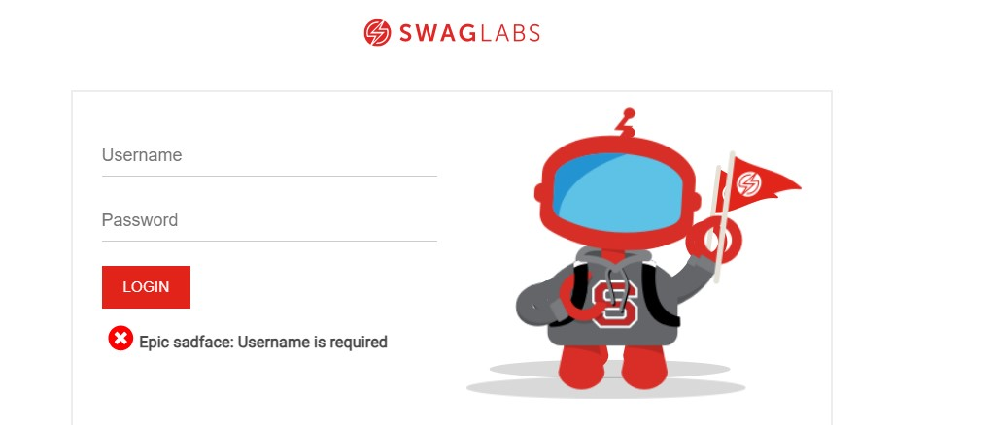

## BUG TITLE: Login Page

## BUG ID: B_002

## ASSOCIATED TEST CASE ID : TC_010

### SEVERITY: High

### PRIORITY: High

### DESCRIPTION:

Verify "Show Password" functionality. Password should be visible when "Show Password" is enabled, but the show password functionality is not present in the website

### STEPS TO REPRODUCE:

1. Open <https://www.saucedemo.com/v1/index.html>
2. Check for the password visibility icon

### SCREENSHOT:

